XB1 Controller Synthesizer

Reference Manual

Intro

The synthesizer operates in two modes, either AM or FM synthesis. It is built with an arpeggiator integrated, two effects (one send, one wet/dry) and lowpass and highpass filters. The complete schematic can be found at the end of the manual.

Note that all buttons can have different modes of operation as follows: momentary (hold down button), latch/toggle (on/off), multi press, combination. I grouped the mappings by category so that it is easier to remember rather than by buttons.

I refer to the buttons using their abbreviation to make the manual easier to read. In case you need it, there’s a reference sheet at the end of the manual.

Oscillators

[A] Toggle between AM and FM synthesis

[X] Enable/disable modulator oscillator frequency modification on [LY]

[B] Enable/disable carrier oscillator frequency modification on [RY]

[LB] Hold down to edit both oscillators’ amplitude factors as follows:

[LX] modulator oscillator amplitude

[RX] carrier oscillator amplitude

[RB] Hold down to edit both oscillators’ sharpness factors (acts like a filter by softening the waveshape, making it look more like a sine) as follows:

[LX] modulator oscillator sharpness

[RX] carrier oscillator sharpness

[D-Pad Left] Cycle through the modulator oscillator’s waveshapes

[D-Pad Right] Cycle through the carrier oscillator’s waveshapes

Available wave shapes:

1. Saw up
2. Saw down
3. Square
4. Triangle
5. Pulse
6. Bi-polar pulse
7. Sample and hold
8. Modulated Sine

Arpeggiator

[LS] Enable/disable arpeggiator on modulator oscillator

[RS] Enable/disable arpeggiator on carrier oscillator

[LS] + [RS] Enable/disable arpeggiator envelope (applies an ADSR on the signal)

[D-Pad Up] Toggle between sequential and random arpeggiator mode (affects the melodic arpeggiator)

[D-Pad Down] Cycle through periodic, scattered, random and Euclidian arpeggiator envelope modes (affects the ADSR envelope and the rate at which new notes are called)

[Y] Edit arpeggiator speed and note length. When in periodic, scattered and random envelope modes, the mapping is as follows:

[LX] Tempo/speed modification (from 20 to 140 bpm)

[RX] Note length (from 0.01s to 0.7s)

When in Euclidian mode:

[LX] Tempo/speed modification (from 20 to 140 bpm)

[RX] Number of onsets per bar (changes the pattern by modifying the number of strong downbeats). Note length is automatically adjusted.

Filters

[A] + [X] Enable/disable lowpass filter (default cutoff is set at 3 000Hz)

[A] Double tap: lower lowpass filter cutoff frequency by 10% (min 500Hz)

[X] Double tap: increase lowpass filter cutoff frequency by 10% (max 22 000Hz)

[B] + [Y] Enable/disable highpass filter (default cutoff is set at 500Hz)

[B] Double tap: lower highpass filter cutoff frequency by 10% (min 20Hz)

[Y] Double tap: increase highpass filter cutoff frequency by 10% (max 1 000Hz)

Effects

[LT] Effect send for the reverb and delay units

[LX] Reverb size

[LY] Reverb damping factor

[RX] Delay time (from 0.001s to 1s)

[RY] Delay feedback (from 0 to 1, so be cautious ☺)

[RT] Wet/dry value for 3D panner

[RX] Left/right panning

[RY] Front/back panning

General

[START] Mute/ Unmute synth

[BACK] Start/stop recording (will create a wave file on your desktop with the date and time of creation)

Annex

Synthesizer schematic

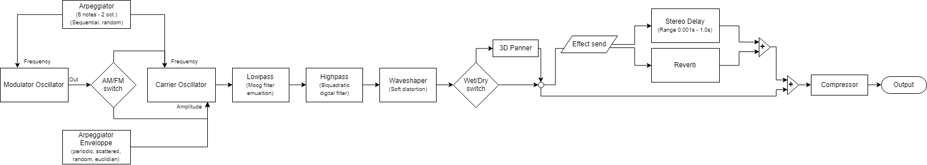

Controller abbreviations reference

|  |  |
| --- | --- |
| Abbreviation | Meaning |
| LS | Left stick button |
| LX | Left stick X-Axis |
| LY | Left stick Y-Axis |
| LB | Left bumper button |
| LT | Left trigger blade (continuous) |
| RS | Right stick button |
| RX | Right stick X-Axis |
| RY | Right stick Y-Axis |
| RB | Right bumper button |
| RT | Right trigger blade (continuous) |
| A, B, X, Y | Face buttons |
| D-Pad | Cross buttons |
| START | Small button to the right of the XBox logo |
| BACK | Small button to the left of the XBox logo |